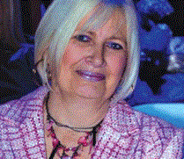

Dr Margit Savović, assistant professor, currently teaches didactics at the Faculty of Education in Jagodina, University of Kragujevac in Serbia. She completed her studies at the Faculty of Philosophy in Novi Sad. In 1996 she defended her doctoral thesis in the field of pedagogy. Her current interest is in innovation in the field of teaching and learning.

